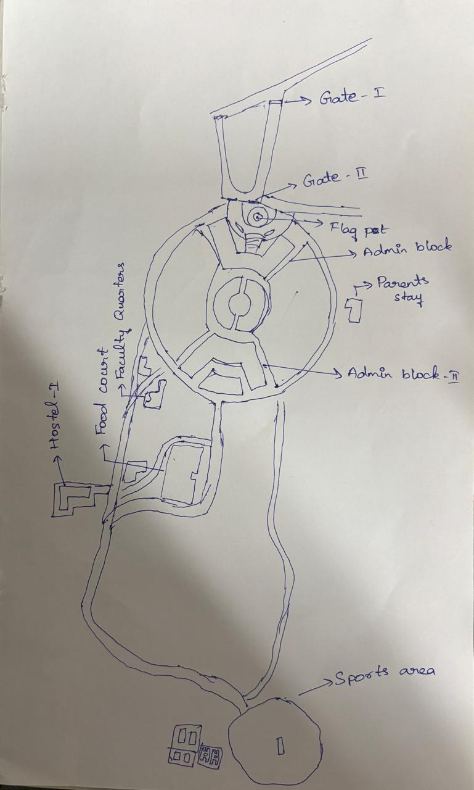Gate 1 → Gate 2 ⇒ 180 m
Gate 2 → Admin block 1 ⇒ 75 m
Gate 2 → Parents hostel ⇒ 283 m
Admin block 1 → Admin block 2⇒ 125 m
Admin block 1 → Parents stay area ⇒ 250 m
Admin block 2→ Food court ⇒ 215 m
Admin block 2→ Staff quarters⇒ 470 m 170 m
Food court → Parents stay area ⇒ 215 m
Admin block 2→ Parents stay area ⇒ 305 m
Food court → Hostel-1 ⇒ 271 m
Hostel-1 → Eng block ⇒ 438 m
Hostel-1 → (Sport area / Ground) ⇒ 565 m
Parents stay area → Food court ⇒ 415 m
Parents stay area → Hostel-1 ⇒ 645 m

